PROMISE & PRACTICE · DEEP DIVE · SOURCE ANALYSIS
Freedom's Institutions — A House Divided
What Freedom Built
Name: ______________________________ Period: _____ Date: ________________
WHAT I CAN DO TODAY I can read primary sources about Freedom's Institutions — A House Divided, weigh who made each one and why, and use evidence to answer historical questions.
Directions. When several sources point the same way, confidence grows. Read them together and name the conclusion

THE SOURCES
THE IMAGE · C.1866 — A freedpeople’s school
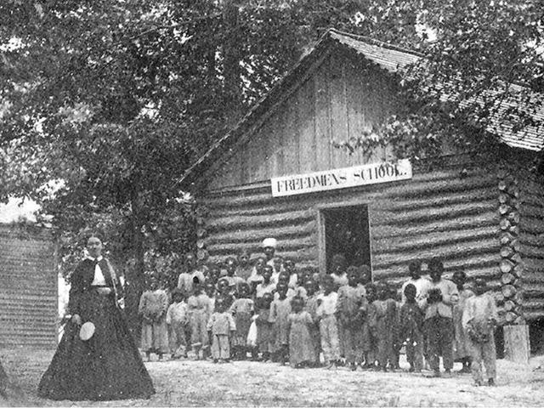
A freedmen’s school, with its teacher and pupils, James Plantation, North Carolina — photograph, c.1866, public domain (Smithsonian NMAAHC / National Archives).
SOURCE · WHAT FREEDPEOPLE CREATED — The institutions of freedom
Independent Black churches (the AME church grew rapidly) · thousands of schools, and the first HBCUs (Howard, Fisk, Hampton) · newspaper ads and long journeys to reunite scattered families · legalized marriages · mutual-aid and benevolent societies · Black-owned businesses.
— summarized from the historical record. Public domain
— summarized from the historical record. Public domain.

YOUR WORK
QUESTION 1 STEP 1 · WHY CHURCHES FIRST
Why were independent Black churches so important beyond religion? Name at least two other roles they played in freedpeople's lives.
____________________________________________________________________________________________
____________________________________________________________________________________________
____________________________________________________________________________________________
QUESTION 2 STEP 2 · WHY EDUCATION MATTERED
Why did freedpeople value learning to read so intensely?
☐ A. it was required by law
☐ B. reading had been forbidden under slavery, so learning was itself a claim to freedom
☐ C. it was easy
☐ D. it had no real importance
QUESTION 3 STEP 3 · CORROBORATION
Churches, schools, family reunions, legalized marriages, new businesses — all point to one conclusion about what freedpeople wanted. In your own words, what is it? How do these different sources corroborate (back up) each other?
____________________________________________________________________________________________
____________________________________________________________________________________________
____________________________________________________________________________________________
____________________________________________________________________________________________
QUESTION 4 STEP 4 · WHY IT MATTERS
Freedpeople were denied land and, soon, political power. In three or four sentences, explain why the institutions they built anyway were so important — and how some of them still shape American life today.
____________________________________________________________________________________________
____________________________________________________________________________________________
____________________________________________________________________________________________
____________________________________________________________________________________________
____________________________________________________________________________________________
Promise & Practice · ShadowDog Digital Studios · Unit 2

TEACHER ANSWER KEY — Freedom's Institutions — A House Divided

QUESTION 1: Open response.
Look for a response along the lines of: “Besides worship, the churches were… and…”
QUESTION 2: Correct — B. reading had been forbidden under slavery, so learning was itself a claim to freedom
Right. Under slavery it had been illegal to teach the enslaved to read. Learning was both a practical tool and a powerful claim to a freedom long forbidden.
QUESTION 3: Open response.
Look for a response along the lines of: “Together these sources show that freedpeople wanted…”
QUESTION 4: Open response.
Look for a response along the lines of: “Even without land or power, these institutions mattered because…”

